**Overview:**

* PatchMeUp is a website that acts as a first aid guide for users, that would help them to patch up themselves during an accident, or advise to seek immediate medical attention if needed, we have included services such as the first aid guide for quick patch ups, their symptoms, and their causes, while also involving causes, symptoms, and treatment tips for serious injuries.
* Other features include a fully navigational map that provides you with the nearest hospitals to the certain given place, we decided to make the center of the map as the university of Jordan, since most our users will be placed there.
* Lastly we have provided the user with lists of emergency contacts that they can use during emergencies.

**User manual:**

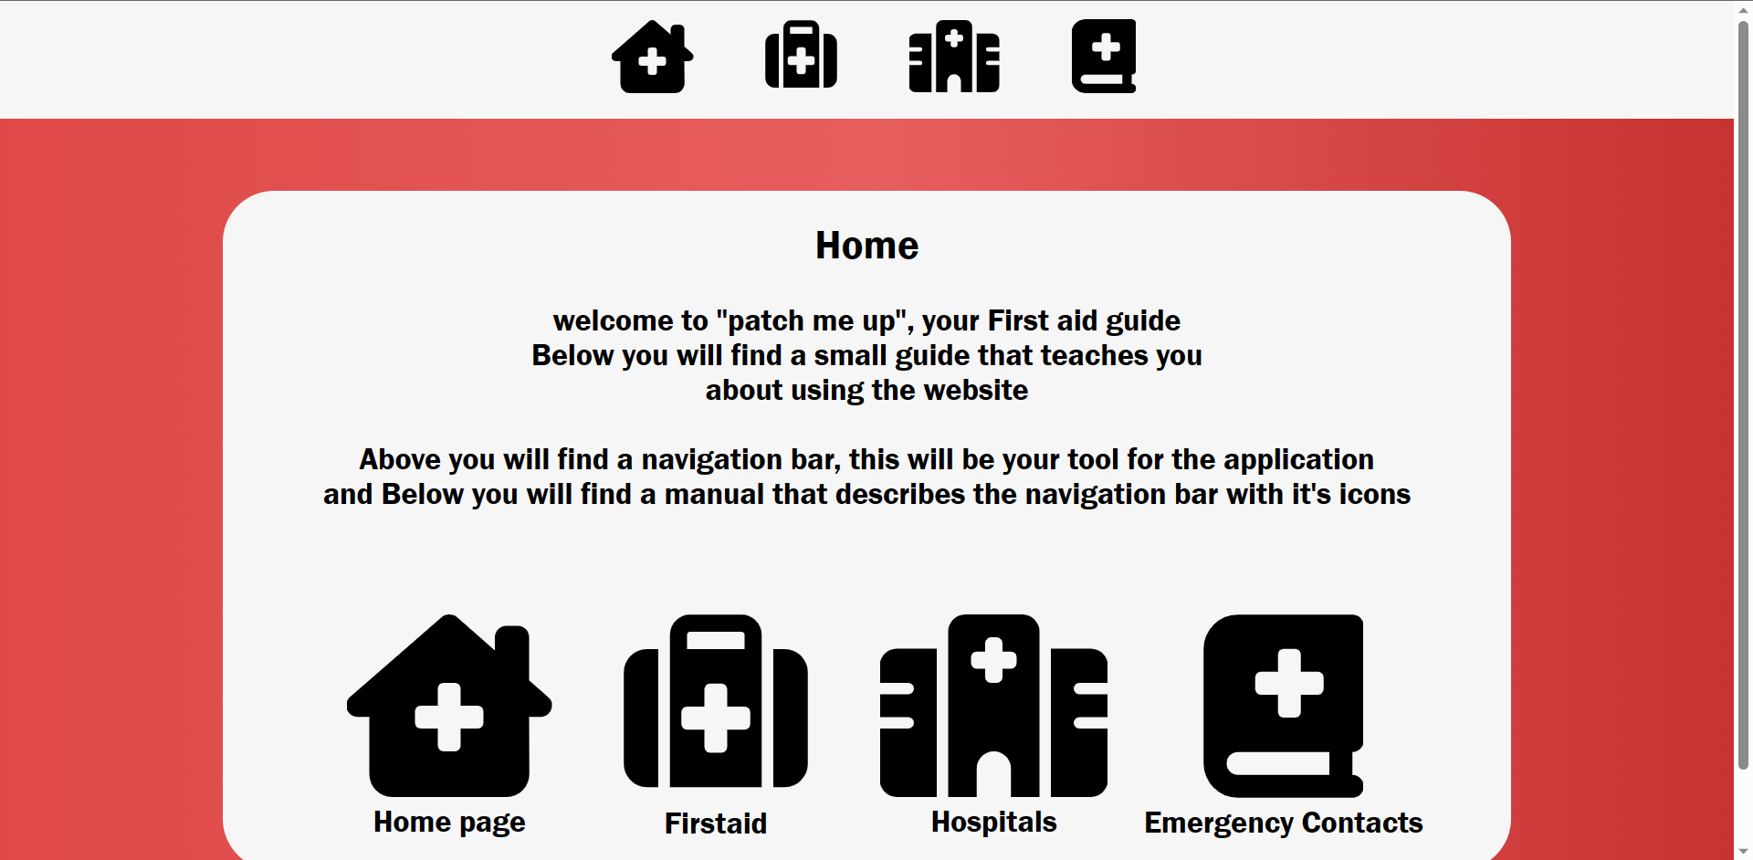

* This is our home page, it involves our navbar that lets you navigate through our website services.
* You will find 4 icons, and descriptions for each one of them, firstly the homke page, secondly you have the first aid guide page, third is nearby hospitals, and last is the emergency contact pages

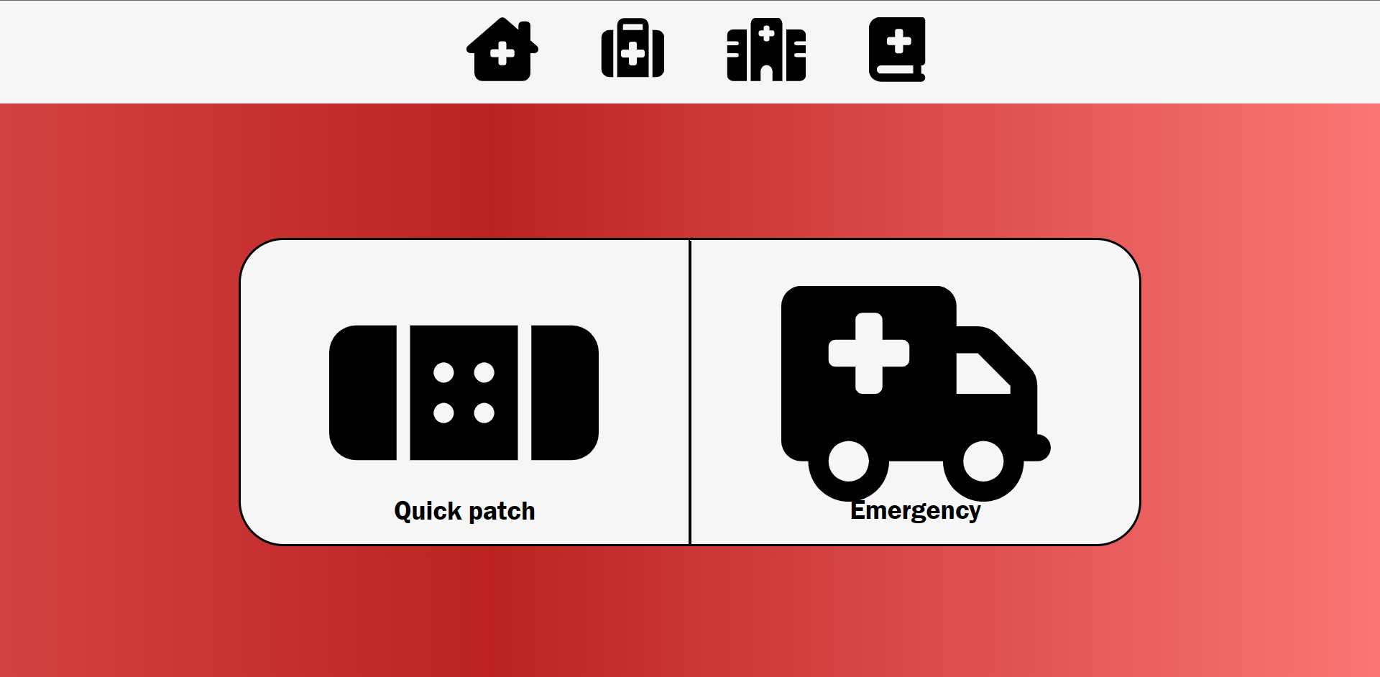

* Upon clicking on the first aid guide button, It will guide you to this page.
* This page has 2 options to click on, on the left we have the quick patch up page, for quick patch ups incase of small injuries, and on the right is the emergency page, it involves tips for injuries that require immediate medical attention.

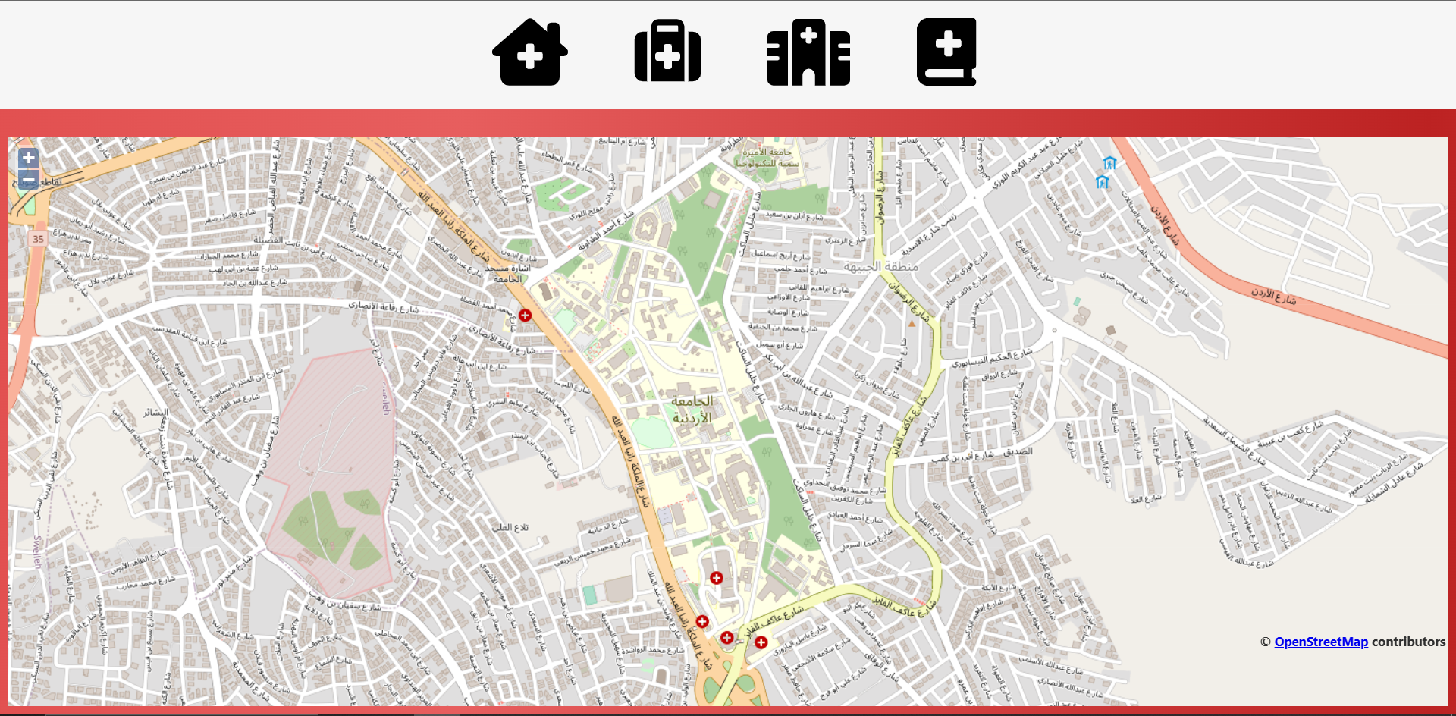

* Upon clicking the hospitals icon, it will guide you to the map page where you can navigate and find the nearest hospitals according to a certain place you navigate to

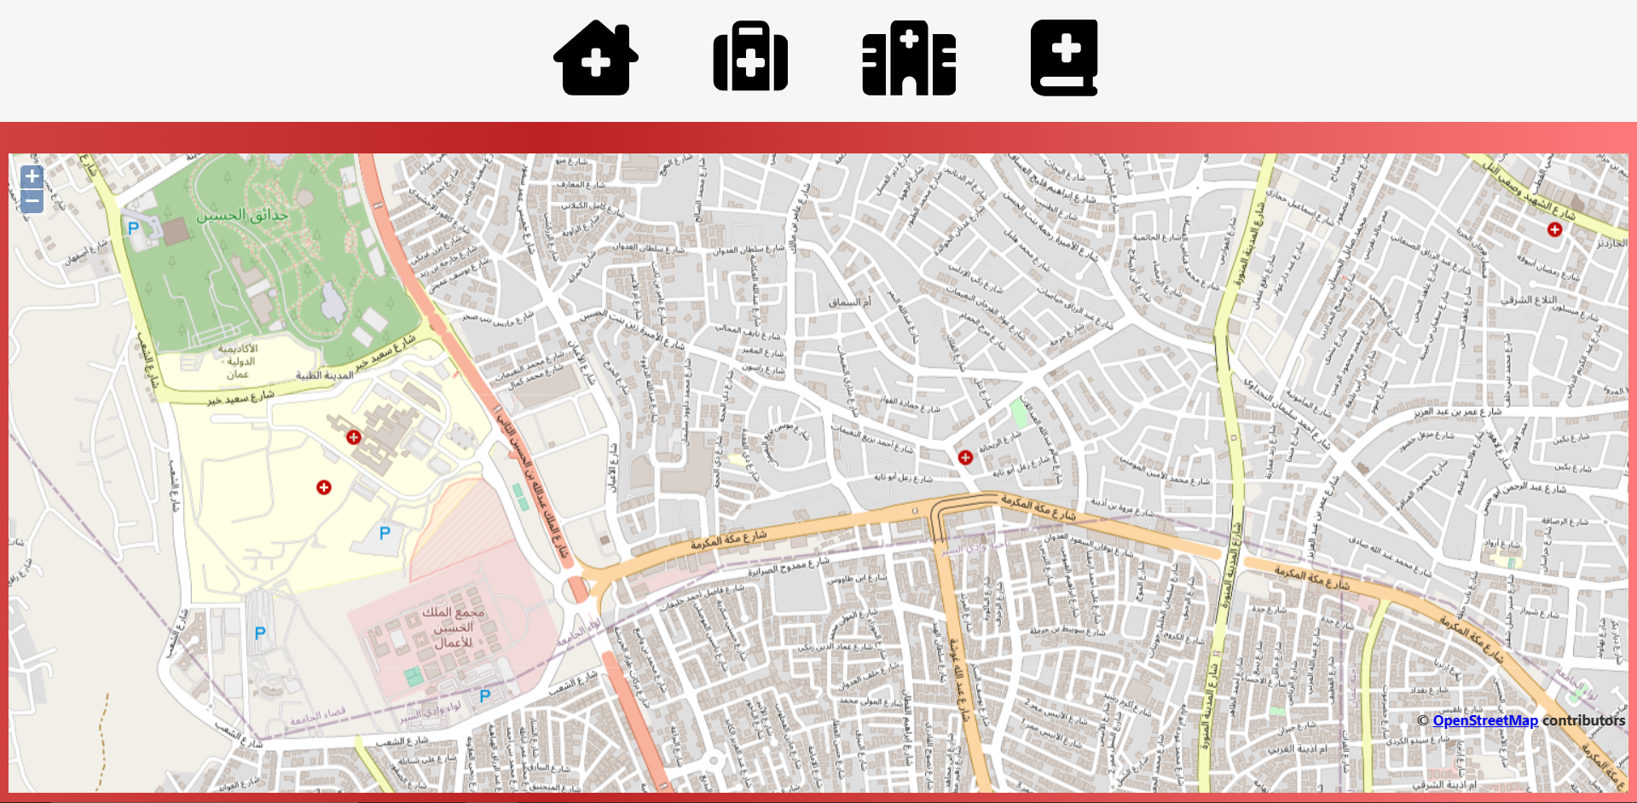

* Upon clicking the emergency contacts icon, it will guide you to the page where you can find the list of emergency contacts you can use